design document for

**Department of Electrical and Computer Engineering**

**MFJ ContinuousCarrier Intellitune**

submitted to:

Dr. Bryan Jones

ECE 4512: Senior Design I

Department of Electrical and Computer Engineering

413 Hardy Road, Box 9571

Mississippi State University

Mississippi State, Mississippi 39762

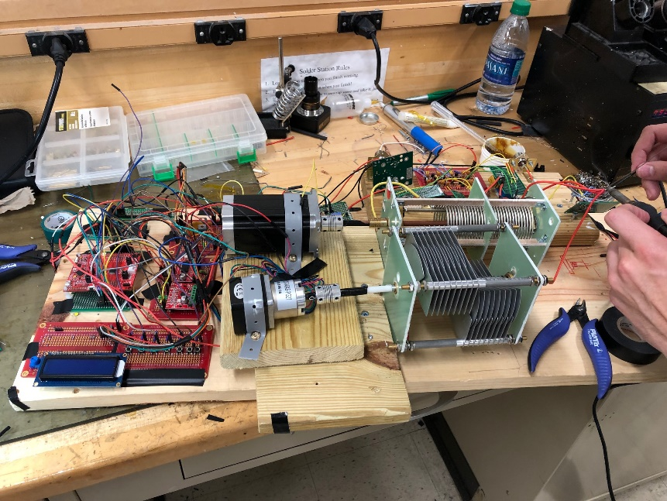

December 5, 2019

Prepared by:

H. Knable, P. Peranich, N. Ihediwah, and J. Stevens

Faculty Advisor: Dr. Mehmet Kurum

Industrial Advisor: Martin Jue, MFJ Enterprises

Department of Electrical and Computer Engineering

Mississippi State University

413 Hardy Road, Box 9571

Mississippi State, Mississippi 39762

email: {hnk50, nci12, jhs345, plp122}@ece.msstate.edu



**LIST OF ABBREVIATIONS**

AC - Alternating Current

ADC - Analog-to-Digital Converter

ATU - Antenna Tuning Unit

DC - Direct Current

EIA - Electronic Industries Alliance

FCC - Federal Communications Commission’s

FM - Frequency Modulation

GPIO - General Purpose Input Output

HF - High Frequency

IEEE- Institute of Electrical and Electronics Engineers

LCD - Liquid Crystal Display

MPE - Maximum Permissible Exposure

NASA - National Aeronautics and Space Administration

PCB - Printed Circuit Board

SPI - Serial Peripheral Interface

RF- Radio Frequency

Ti - Texas Instruments

VDC -  Volts Direct Current

VSWR - Voltage Standing Wave Ratio

**Executive Summary**

In amateur radio, an antenna tuning unit (ATU) is a critical component used for matching the connected antenna’s impedance to that of the transmitter. With a matched impedance network, the transmitter operates at maximum efficiency, which results in a better operating experience. Current ATU offerings are comprised of two main categories: manual tuners which utilize variable tuning components with gears attached for user adjustment and auto tuners composed of discrete components and relays to adjust impedance values. The Intellitune aims to bridge the gap between these offerings by automatically tuning with variable components. Figure 1 shows an overview of the Intellitune and its features.

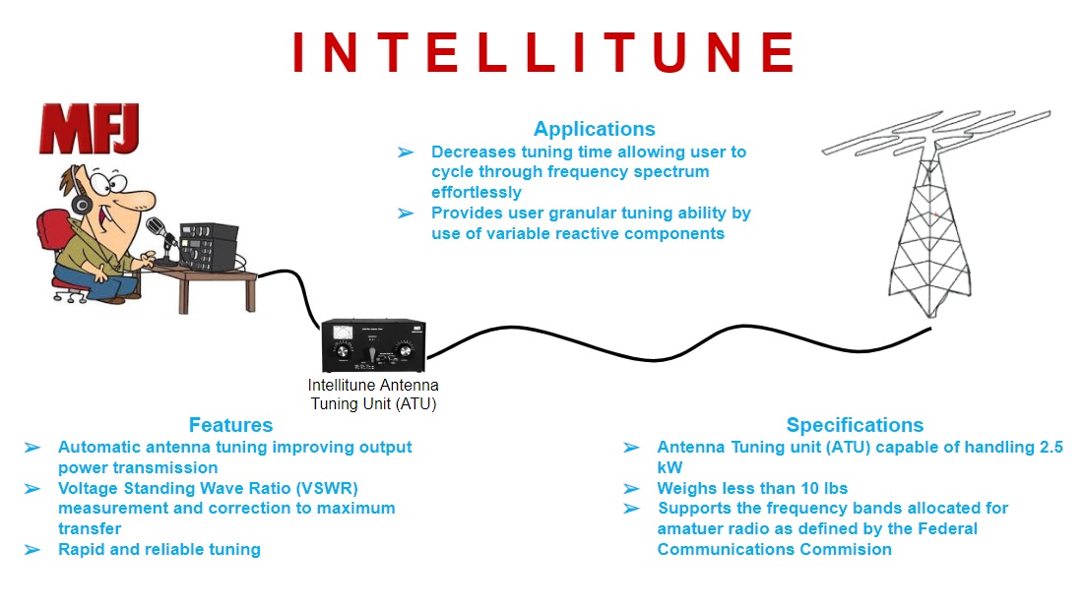

**Figure 1 - Intellitune Overview**

The Intellitune must meet certain design criteria to fulfill the needs of amateur radio operators. The operating frequency for the Intellitune is 1.5 MHz to 30 MHz, which effectively covers the most popular band among ham radio enthusiasts, the HF band. In addition, the 1.5kW power rating will enable operators to communicate across long distances without a repeater. In everyday use, the Intellitune must be safe to handle, with proper grounding channels connected to ensure no charge builds on the surface of the enclosure. Finally, the Intellitune must be no larger than a similar MFJ tuner, with dimensions 13” x 7” x 15.72” in order to fit in most amateur radio setups with ease.

To accomplish automated tuning, two primary subsystems were devised. The tuning network matches the load impedance to the transmitter, and the control circuit drives the matching network, adjusting the tuning components to the correct values for a given frequency. The RF signal enters the tuning network, where it is passed through the VSWR sensor and the matching network. After the tuning components, the RF signal exits the tuner where it connects to the antenna. On the control circuit, the primary inputs to the tuning algorithm are the VSWR sensor and the frequency counter. In addition, the control circuit will drive stepper motors to adjust the variable capacitor and inductor to match the network.

Most current auto tuners utilize a tuning network composed of purely discrete reactive components. This means that the auto tuner can find the lowest VSWR for a given frequency, but there will still be room for improvement since discrete steps between each setting are present. The Intellitune introduces a variable capacitor and roller inductor to the tuning network, which allows continuous tuning through a range of values. This approach allows the user to reach the lowest VSWR for each frequency tuned.

**Table of Contents**

1. Problem 4

2. Design requirements/constraints 6

2.1. d2.3. Appropriate Engineering Standards 10

3. Approach [minimum length: 10 single-spaced pages; maximum length: 30 single-spaced pages] 11

4. Evaluation [minimum length: 8 single-spaced pages; maximum length: 15 single-spaced pages] 25

5. Summary and future work 31

6. Acknowledgements 32

7. References 32

8. Appendix: Product specification 35

# Problem

**1.1 Historical Introduction**

Ham radio history dates back to the discovery of electromagnetic waves. In 1894, six years after electromagnetic waves were proven to exist by Heinrich Hertz, Guglielmo Marconi produced the first successful radio transmission, opening the door for the amateur radio operator. In the beginning, ham operators could communicate with as little as a bundle of chicken wire, but some crude methods like the spark-transistor lead to problems such as interference with commercial and government. This led to development of regulation by the federal government. Regulation stunted the growth of ham radios, but did not stop it. By 1912, ham radios were capable of reaching one hundred miles. As progress came, so did more regulation. In 1912, they also limited ham radio wavelength to 200 m and required a permit in an attempt to discourage use.  The creation of the tube operated regenerative receiver in 1913 furthered developments, but was short lived as WWI started shortly after. Ham radio continued to endure, and in 1924, the first trans-Atlantic transmission was produced between England and New Zealand using a 110 m wavelength proving the benefits of a shorter wavelength. By the 1930’s, tube technology became more economical allowing greater growth.

Nikola Tesla was the first person to publicly feature a wireless system with similar tuning concepts in use today. Soon after, many different circuit designs were developed based on Tesla’s model [1]. As ham radio growth continued, so did the need to implement some of the same tuning concepts demonstrated by Tesla. Basic tuning concepts that telecommunications and other RF shared, such as an L and T network, were introduced.  Most tuning processes were traditionally done using a manual tuning unit which had variable capacitance and impedance to offset interference. Manual tuning became the standard until MFJ introduced an automatic tuning unit, which we will improve upon.

Even today, ham radios are still common, and have sparked interest for over one hundred years including two world wars, various moon landing, the dot com bubble, and through to the high tech world of today. As Ham radios have endured so has their need to be tuned. As of right now there are not many manufacturers that can deliver a high powered reliable automatic tuning experience for the day to day ham operator. Our automatic tuning unit will bring a more economical and reliable product to ham radio operators as we hope to add our own contributions to the long history of ham radios.

**1.2 Market and Competitive Product Analysis**

In the United States alone, the amateur radio community is large and growing. The Federal Communications Commission’s (FCC) Universal Licensing System database reports 821,255 active ham radio licenses [2]. With this large of a community a market is present that the autotuner can satisfy. Palstar’s AT4K antenna tuner is a comparable product priced at $899 and is rated up to 2500 Watts. The Intellituner will excel due to its microcontroller and lower price. Radio consumers can turn to the Intellituner for continuous automatic tuning versus manual tuning the AT4K and other tuners offer.

The Intellituner is based off of the MFJ-9982 manual tuner that employs a variable capacitor and inductor and the MFJ-998 autotuner that implements relays for impedance matching. The Intellituner takes pieces from both designs and optimizes them in a new and improved model. Saved impedance configurations for previously used frequencies will provide faster tuning speeds for autotuner users. This model will also attract radio operators that were satisfied with the previous 998 model but looking to automate the tuning process.

**1.3 Concise Problem Statement**

As the ham radio operator changes the frequency in which they are operating on, the antenna impedance changes, however the impedance of the transceiver always remains the same. This created an issue because the transceiver and antenna impedances must be matched in order to operate at peak efficiency. This causes the user to be tasked with “tuning” their radio, or adding capacitance and inductance, to create this necessary impedance match. For years, ham radio users have been forced to adjust the antenna impedance manually in order to operate the radio at peak efficiency. Since this has been a manual process, it is time consuming and leaves room for human error. Our product aims to eliminate these concerns by letting Intellitune’s technology complete the tuning process automatically.

In the past, antenna tuners have been manufactured to simplify the tuning process, but our product wishes to take this a step further. The Intellituner will read in the value of the Voltage Standing Wave Ratio (VSWR) and adjust variable capacitors and inductors in order to create an impedance match, lower the VSWR, and achieve maximum power transfer. Our product will also have the ability to save the tuning parameters for various frequencies for future uses. A huge advantage of this product is that it will require less maintenance on the hardware due to a more efficient design that implements fewer relays.

**1.4 Implications of Success**

Upon successful completion of our automatic tuner, it can be used as a more efficient, reliable, and effective alternative to what is already available. Some ham users in the past might have been reluctant to buy an auto tuner because of the unreliability (did not want to service annually/biennially) and opt for the reliable manual one, but our product will be able to meet the needs of those looking for a product that is both automatic and reliable. Our product shares its base tuning components with that of the manual tuner which have proven to last. These parts also allow for a better “tune” because of the variability they have. Our design allows for more specific tuning control. Operators need a tuner so impedances on either side will match and they will have maximum power transfer between their respective transmitter and antenna. This allows for farther transmission distances.

Our product will not necessarily bring any new consumers into the market, because it is not a product that has changed the landscape of ham radios. However, our product improves the function of the ham radio. Intellitune will be able to attract those ham users who want a tuner that not only will not burn up, but also provide automatic tuning. Standard automatic tuners in the market have proven unreliable which may lead ham operators to stray away. These operators will see a new product with a competitive price enabling them to upgrade their equipment. We hope that the improvements implemented in our design will attract the consumer to purchase our product.

The Intellituner will be a positive advancement in the ham radio community. With the continuous rise in ham radio popularity, the Intellituner can be turned to by consumers looking to save their time and money. In emergency situations or natural disasters where no electricity or internet is available, amateur radios provide effective communication for the individuals involved. Our product can be utilized in these situations with its assured performance. For users with ham radios as their hobby, the Intellituner will ease operation and make the radio experience more enjoyable.

Reference:

# Design requirements/constraints

Intellitune is an automatic antenna tuning unit (ATU) for use in a ham radio setup where it fits between the radio transmitter and the antenna. Traditionally, a ham operator would manually tune the impedance of the network so that the transmitter could operate at maximum efficiency. The Intellitune aims to eliminate this time-consuming process by automatically tuning the network, allowing the user to operate the radio faster and with more ease. Once tuned, the transmitter will operate near its peak efficiency for the given setup, enabling the user to transmit a cleaner signal with less interference. To successfully implement this project, the design must abide by certain contraints. Section 2.1 provides a description of five technical constraints, followed by section 2.2, which elaborates on five practical constraints. Finally, section 2.3 will detail the engineering standards which pertain to the Intellitune.

**2.1. Technical Design Constraints**

Table 2.1 describes the technical specifications that the Intellitune must meet upon completion.

Table 2.1. Technical Design Constraints

|  |  |
| --- | --- |
| **Name** | **Description** |
| Power Rating | The Intellitune must be capable of handling 1.5 kW of transmitting power. |
| Bandwidth | The Intellitune must tune frequencies in the 1.5 MHz to 30 MHz band. |
| VSWR Sensing | The Intellitune must measure the forward and reflected power to determine the voltage standing wave ratio (VSWR) for up to a 32:1 mismatch with a +- 8% maximum error. |
| Frequency Sampling | The microcontroller must sample the transmitting signal and determine the frequency up to the maximum 30 MHz limit with a +- 2% maximum error. |
| Impedance Matching | The Intellitune must provide a tuning network that is capable of matching antenna impedances from 12-1600 ohms. |

**2.1.1. Power Rating**

The Intellitune must be capable of functioning at a transmitting power of 1.5 kW. This power rating is the highest limit within regulation [3], and the rating places the Intellitune in a strategic position among competitors, most of which are not capable of operating at such high power. The Intellitune will tie into the transmission line fed from the radio transmitter, after which it will connect to the variable inductor and variable capacitor. A single relay will be used to switch the capacitor onto each side of the inductor. Therefore, each part aforementioned must be rated to a minimum of 1.5 kW. In addition, connections between each stepper motor and their respective reactive component, either the variable inductor or variable capacitor, must have proper insulation and protection to prevent transmission power from flowing through the control circuit.

**2.1.2. Bandwidth**

The Federal Communications Committee (FCC) allocates specific frequencies in the RF spectrum for varying applications, and the spectrum allocated to amateur radio is described in 47 CFR 97.301 [3]. Intellitune must be designed to operate in the 1.5 MHz - 30 MHz band, which encompasses most of the FCC-allocated band and is the most popular for ham radio operators.

**2.1.3. VSWR Sensing**

The Intellitune must sample the forward and reflected power on the RF feedline to determine the VSWR for up to a 32:1 mismatch. Past a 32:1 reading, it is difficult to extract useful information from the measurement. The tuning algorithm utilizes the VSWR reading for many of its calculations, so inaccurate or intermittent measurements will significantly impact performance. Therefore, the sensing circuit for VSWR must be sufficiently robust to minimize any errors.

**2.1.4. Frequency Sampling**

The microcontroller must read the frequency of the transmitted RF wave for the tuning algorithm to function as desired. Frequency is a key component in determining the impedance of the antenna. Thus, the entire tuning process hinges on interpreting the frequency with a high level of confidence. Since the Intellitune is designed to operate at a maximum frequency of 30 MHz, Intellitune must incorporate a frequency counter that will convert the signal from analog to square so that the microcontroller can interpret and give correct frequency measurement. The sampling interval must be at a rate which allows for proper counting of RF signal peaks, while still providing enough computational resources for other critical measurements.

**2.1.5. Impedance Matching**

The Intellitune must provide a matching network capable of regulating the impedance observed by the signal source. It will be designed to match a transmitter, transceiver, or amplifier to any antenna with an impedance ranging from 12 to 1600 ohms. This is highest allowable impedance match that our components will allow. Standard coaxial cables used for radio transmission typically have an intrinsic impedance of 50 ohms, so matching this amount minimizes the reflected radio frequency (RF) power in the system. If the antenna’s impedance is not matched, low power transfer and poor transmission quality will be observed at the transceiver. This will directly affect the radio operator’s experience, causing frustration and grief.

**2.2. Practical Design Constraints**

Table 2.2 describes the practical design constraints that must be followed for a successful execution of the final product.

Table 2.2. Practical Design Constraints

|  |  |  |
| --- | --- | --- |
| **Type** | **Name** | **Description** |
| Health and Safety | Physical Safety of the User | The product enclosure must be safe for human contact. |
| Manufacturability | Size | Size must be compact and within a two-inch range of previous comparable antenna tuning units (13” x 7” x 15.72”). |
| Sustainability | Longevity | The device must support 100,000 tuning cycles before requiring maintenance. |
| Economic | Price | The cost must be comparable to currently available tuning units, around $700. |
| Environmental | Heat dissipation | The max allowable temperature of the outer case must be 45 degrees Celsius (113 degrees Fahrenheit). |

**2.2.1. Health and Safety**

Ensuring user safety is critical, so the auto tuner must not pose any potential risks to users during operation. The Intellitune may handle up to a 1.5 kW load, but this high load presents the risk of electrocution. The design must ensure that all potentially dangerous RF current is isolated from the enclosure surface. Therefore, the Intellitune must be placed in a durable yet lightweight enclosure that provides adequate grounding so surface charge does not accumulate.

**2.2.2. Manufacturability**

The size of the tuning unit must be suitable to fit in ham radio work stations. Ham radio users typically set up their radio equipment on a desk or workbench, so the Intellitune cannot be oversized such that it will not fit in a typical setup. The current and comparable MFJ-9982 model measures 13” x 7” x 15.72” [4]. The Intellitune employs similar components so the final product should remain within two inches of these dimensions, in each direction, to provide a compact automatic tuner.

**2.2.3. Sustainability**

The Intellitune must have a lifespan of 100,000 tuning cycles between maintenance intervals. A multitude of relays are used in the MFJ-998 model, which burn out and require service more frequently than other parts within the tuner [5]. Therefore, the Intellitune must feature a reduction of relays to increase the reliability of the product.

**2.2.4. Economic**

The Intellitune must be priced at $700 to remain competitive in the marketplace. One comparable model, the MFJ-998, is offered at $699.95. The Intellitune features a more reliable and higher-rated design, while maintaining a similar cost [5]. In-house manufacturing and off-the-shelf components will reduce manufacturing costs.

**2.2.5. Environmental**

The Intellitune must be capable of passing the rated power to the antenna without rapid heating. The enclosure must be safe to touch after operating at maximum power. According to a NASA study, the highest temperature that a human can safely come in contact with is 45°C (113°F) [6]. Additionally, if extreme heating were to occur, the risk of fire from contact with the ATU would reduce the safety of the unit. Furthermore, the enclosure must be robust enough to sustain minor bumps or collisions with other equipment when moved.

## 2.3 Appropriate Engineering Standards

While satisfying the practical and technical constraints, the Intellitune must also abide by the specific engineering standards detailed in table 2.3.

Table 2.3. Appropriate Engineering Standards

|  |  |  |
| --- | --- | --- |
| **Specific Standard** | **Standard Document** | **Specification / application** |
| EIA-RS-225A | 50 Ohm EIA Standard Connectors | The coaxial RF connectors used in the Intellitune will adhere to the Electronics Industries Alliance (EIA) standard. |
| C95.1 | IEEE Std C95.1-2005 | This is the Maximum Permissible Exposure (MPE). |
| FCC e-CFR 97.301 | Electronic Code of Regulations | These are the authorized frequency bands. |

**2.3.1 EIA-RS-225A**

Since Intellitune will be working as one part of a system comprised of the user’s other ham radio equipment, it is imperative that everything on the tuner is compatible with the system as a whole. The physical connections made between the RF cables must carefully be taken into consideration so as not to cause any interference between equipment. For this reason, the design of the 50-ohm RF connectors must strictly adhere to the description found in EIA-RS-225A.

**2.3.2 C95.1**

The Intellitune is an RF device, so it follows that RF energy could escape the main transmission line and radiate elsewhere. C95.1 specifies the maximum allowable electromagnetic energy that may be radiated into free space, referenced as MPE. The MPE limit must be met to ensure user safety from RF radiation [7].

**2.3.3 FCC e-CFR 97.301**

Amateur radio has specific sets of frequency bands to which operators must adhere based on licensure. Intellitune must adhere to these standards, and it should not promote or permit violating the FCC regulations [3].

# Approach

The Intellitune is an automatic antenna tuning unit (ATU) that enables ham radio operators to tune their antenna at the press of a button. An L matching network provides the required impedance range to support 1.5 MHz to 30 MHz operation, which encompasses all the high frequency (HF) band. Using an LCD and several pushbuttons, the operator may view tuning settings or touch up the impedance levels after the tuning algorithm has been completed. The summation of these features results in an ATU that meets the needs of both experienced and beginner ham operators alike.

**3.1 System Overview**

The Intellitune consists of two isolated circuits: the radio frequency (RF) circuit and the control circuit. Proper isolation between these circuits is necessary to prevent RF energy from entering the control circuit. Figure 3.1 depicts a high-level overview of the Intellitune and its subsystems.

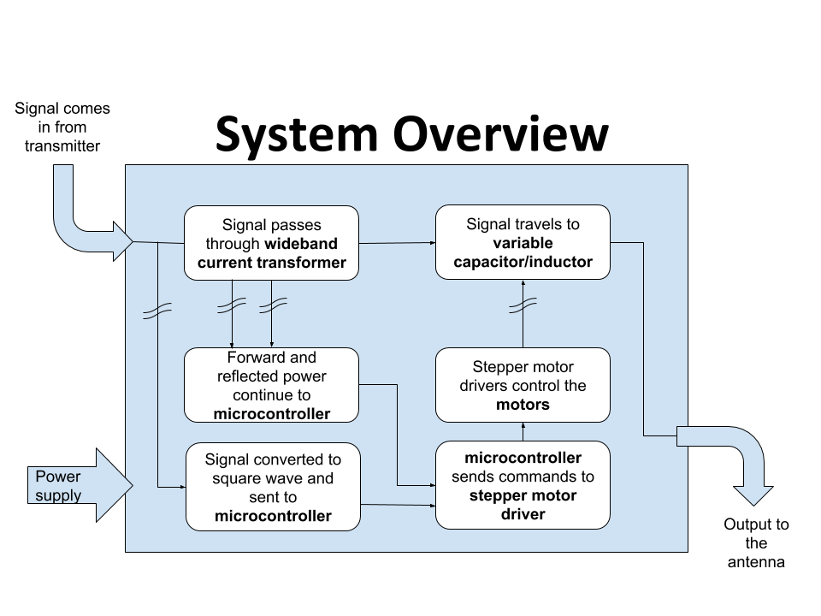

**Figure 3.1 - Intellitune System Design; wavy symbols across the lines represent isolation.**

The RF signal enters the Intellitune, where it passes through a wideband current transformer. Next, it continues through the variable tuning components and out to the antenna. Separate ground paths between the RF circuit and control circuit will be maintained. A connection will be made between the two at a single point, at which a choke is placed to minimize the amount of RF energy flowing between the ground paths. The wideband current transformer and frequency counter are critical inputs to the control circuit. Two stepper motors are the driving force behind the Intellitune matching network and are controlled by the output of the tuning algorithm. A 16x2 LCD display shows useful information to the user, and six pushbuttons interface the user with the product.

**3.2 Hardware**

The Intellitune consists of many subsystems that integrate to perform the tuning process. The hardware includes a power supply, wideband current transformer, microcontroller, stepper motors and drivers, variable inductor and capacitor, a relay circuit, enclosure, and LCD display. The microcontroller will tie all the subsystems together. Additionally, there will be a dummy load constructed to act as the antenna for testing purposes.

**3.2.1 Power Supply**

The Intellitune requires 12 VDC to operate the control circuit, and since the tuner will always be stationary during use, a wall-mounted supply is a sensible option. Therefore, a 12 VDC AC adapter was selected for the power source, as listed in Table 3.1.

**Table 3.2a - Power Supply Selection**

|  |  |  |  |
| --- | --- | --- | --- |
| **AC Adapter** | **Voltage** | **Current** | **Price** |
| MFJ-1312DX [8] | 12 VDC | 500 mA | $15.95 (Free) |
| SUPERNIGHT 12V Power Supply [9] | 12 VDC | 2 A | $6.98 |
| BINZET AC to DC 12V 10A 120W Power Supply Adapter Converter Regulator [10] | 12 VDC | 10 A | $17.58 |

|  |  |
| --- | --- |
| Selected Option | Not selected |

The power supply chosen was the MFJ-1312DX because it met all the power requirements for the project and was provided at no charge from MFJ.

**3.2.2 Wideband Current Transformer**

In electromagnetics, the voltage standing wave ratio (VSWR) relates the transmitted power to the reflected power in a transmission system. Figure 3.2 provides an example of a transmitted wave that has a reflected component.

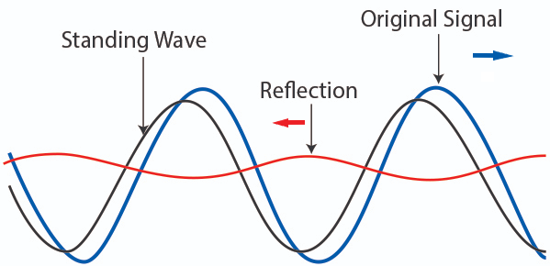[11]

**Figure 3.2a - Standing Wave example**

The blue wave in the above figure represents a transmitted signal traveling to the right on a transmission line. Suppose it encounters a load whose impedance does not match that of the transmission line. This will result in most of the wave being transmitted into the load, but a portion is reflected to the source, as represented by the red wave. The grey wave is a superposition, or combination, of the two waves, and it receives the name “standing wave” because it appears to oscillate in place through time unlike the original or reflected wave. The amount of power reflected is directly proportional to the mismatch in the load, and a reflection coefficient is used to relate the mismatch in impedance to the amount of reflected power:



ℾ: Reflection coefficient

ℾ: Reflection coefficient

Vref: Voltage of reflected wave

Vincident: Voltage of original wave

ZL: Impedance of load

ZS: Impedance of source

Voltage standing wave ratio (VSWR) is calculated from the reflection coefficient with the following formula:



VSWR: Voltage standing wave ratio

Vmax: Maximum voltage of the standing wave

Vmin: Minimum voltage of the standing wave

From the above formulas, it is evident that if the VSWR of a signal is known, the amount of reflected power can be estimated. If an antenna tuner introduces more inductance or capacitance to the system, the VSWR will change. In the Intellitune, the VSWR will be measured with a wideband current transformer. Figure 3.3 shows a typical implementation of a wideband current transformer.

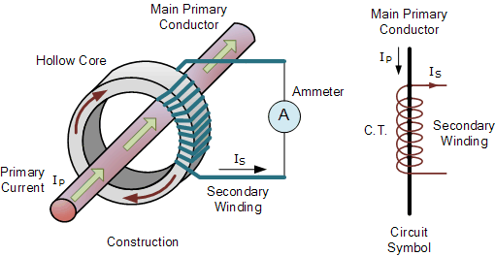[12]

**Figure 3.2b - Wideband Current Transformer**

The RF feedline passes through the center of a toroid, where a secondary winding is wrapped around the hollow core. This device appears similar to a step-up transformer schematically, but in operation, it is used to make a proportional measurement of the RF current in the feedline. In the Intellitune, a center tap on the current transformer allows two different measurements from which forward and reflected voltages can be derived. A sensor from Ameritron, a sister company to MFJ, will be used in the design since it is rated above the target 1500W, and no other wideband current transformer can satisfy this requirement

**3.2.3 Microcontroller**

The Intellitune requires a microcontroller in the control circuit to calculate the tuning parameters and interface with peripherals. The most important requirement for the microcontroller is that it must have at least 36 general purpose input/output (GPIO) ports. This is due to the complexity of Intellitune’s circuitry resulting in numerous different data lines that must be connected to the microcontroller. Table 3.2b provides three of the microcontrollers that were considered for the Intellitune.

**Table 3.2b - Microcontroller Selection**

|  |  |  |  |
| --- | --- | --- | --- |
| **Microcontroller** | **GPIO Ports** | **Clock Speed** | **Price** |
| Arduino Uno Rev3 [13] | 14 | 16 MHz | $22.00 |
| Raspberry Pi 3 Model B+ [14] | 40 | 1.4 GHz | $35.00 |
| Ti MSP-EXP430FR2355 [15] | 40 | 24 MHz | $12.99 |

The Ti MSP-EXP430FR2355 Launchpad microcontroller was selected for several reasons. To begin, this microcontroller has many peripherals required for the design, specifically, external timer capability, four total timers, 40 pins broken out to headers, 12-bit ADC channels, and a serial peripheral interface (SPI) communication module. Prior experience developing with similar Ti products influenced the decision as well. Finally, this microcontroller was the least expensive compared to similar products.

**3.2.3.1 Frequency Counter**

The frequency of the transmitted wave is another important parameter for the tuning algorithm. When considering common methods of frequency sampling, two were identified. One method commonly used for determining the frequency content of a sampled wave consists of sampling the desired signal at a frequency greater than the Nyquist Rate, defined as twice the bandwidth of the signal. Sampling at this rate allows for complete frequency decomposition using a Fourier Transform, but for the Intellitune, this rate would be at least 60 MHz, twice the highest expected frequency. Microcontrollers capable of sampling at this rate are much more expensive, and the additional frequency content is not used by the Intellitune. Since the frequency counter is only concerned with the signal’s center frequency, a simpler design is sufficient. Figure 3.9 displays the chosen method of deriving the frequency of the RF signal.

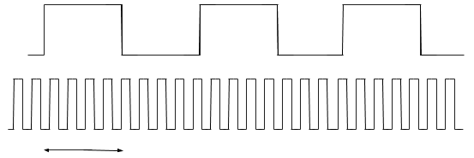



**Figure 3.3e - Frequency Counter timers**

The method pictured above uses two timers to determine the center frequency of the transmitted wave. A small portion of the RF signal is converted into a square wave as it enters the Intellitune and is then routed to the microcontroller. The square wave acts as the clock source for one timer, where it will increment a variable for each rising edge. This timer source is prescaled, or divided down, by a factor of 16 to decrease the total amount of pulses. An additional overflow register increments when the timer count exceeds its max value, which is 65,535 for the 16-bit timer variable. A separate timer will have a fixed known period of length one second in this implementation, which will allow precise measuring of the number of pulses in the interval. Using these two values, the number of pulses and the length of the gate interval, the frequency of the wave can be derived.

**3.2.4 Stepper Motors and Couplings**

The variable capacitor and inductor each have a shaft that must be turned in order to change the component values. Initially, the three types of motors considered were stepper motors, DC motors and servo. However, it was quickly discovered that stepper motors provide precise tuning compared to a standard DC motor or servo. By having a set degree of rotation for each step, i.e. one degree will give a 1/360th of a complete rotation, stepper motors can be as precise as the step angle allows. To achieve something similar to stepping in a standard DC motor, much more software development would be required. In addition, continual starting and stopping has detrimental effects on a DC motor’s lifetime, often resulting in premature failure.

After selecting the type of motor Intellitune required, the different models of stepper motors were narrowed down by several other required specifications. One  requirement of the motors is that they must be able to step both clockwise and counterclockwise, because depending on the current position of the variable components, they may have to increase or decrease to a desired value. All motors listed in Table 3.3 have dual directionality. Additionally, the variable components require no holding torque to maintain a constant position, however, with everyday use such as moving to desired set up, some holding torque is required. Although not listed in the table, every motor has holding torque that will allow it to hold in everyday situations (>1Ncm). Once the motors arrive at their desired position for the tuning process, their location will be stored in the microcontroller for future reference.

**Table 3.2c - Stepper Motor Comparison**

|  |  |  |  |  |
| --- | --- | --- | --- | --- |
| **Motor** | 23HS41-1804S [16] | 17HS13-0404S-PG27 Nema 17 [17] | (3)11HS20-0674S-PG100  Nema 11 [18] | (4)17HS19-1684S-PG5  [19] |
| **Maximum Torque** | 240 N*cm | 300 N*cm | 400 N*cm | 200 N*cm |
| **Voltage** | 4.95 V | 12 V | 6.2 V | 2.3 V |
| **Current rating** | 1.8 A | 0.4 A | 0.067 A | 2.8 A |
| **Step angle** | 1.8 degrees | 0.067 degrees | 0.018 degrees | 1.8 degrees |
| **Price** | $25.91 | $26.87 | $34.72 | $55.59 |

Stepper motors in Table 3.3 meet the requirements specified in the previous paragraph. The shafts on the variable components were so small that it was not possible to find a torque wrench small enough to obtain a torque measurement. Therefore, a trial with a stepper motor that could turn the variable components was done, and the 17HS13-0404S-PG27 (PG27) was determined to have enough torque and deemed suitable for the variable capacitor.

The variable capacitor only requires one complete rotation to cycle through all of its values, so a lower step angle allows for more values of capacitance. Therefore, the motor chosen for the capacitor has a 0.067-degree step angle. Since there are 360 degrees per revolution, this motor will be capable of providing 5373 unique values of capacitance.

On the other hand, the variable inductor has a comparable torque but requires 31 rotations to cycle through all values of inductance, therefore such a small step angle is not necessary like it was with the variable capacitor. Model 23HS41-1804S was the best option because of its 1.8 degree step angle and comparable torque. With the 31-revolution cycle and larger step angle, 6200 unique values of inductance are available for Intellitune to utilize. Furthermore, 23HS41-1804S was more cost effective than 17HS19-1684S-PG5, and it also has a lower current rating, allowing for more compatibility with drivers.

In order to achieve precise values of impedance, it is crucial that the shafts of the stepper motors have a secure connection to the variable components. A coupling is needed that adjusts on both ends since the stepper motor shaft and adjuster shaft on the variable components do not have the same diameter or shape. Additionally, a flex spiral cut feature in the coupling limits binding caused by the difference in diameters. Table 3.4 displays couplings of various sizes that were considered.

**Table 3.2c - Coupling Comparison**

|  |  |  |  |
| --- | --- | --- | --- |
| **Size** | 5mm to 8mm [20] | 5mm to 10mm [21] | 3mm to 5mm [22] |
| **Feature** | Flex | Flex | Flex |
| **Price** | (2) $6.20 | (1) $4.95 | (1) $8.88 |

Note: All couplings are made of aluminum

The diameters of the stepper motor shaft 1, motor shaft 2, variable inductor shaft, and variable capacitor shaft are 5mm, 8mm, 5mm, and 7mm respectively. The couplings are adjustable via set screw design, and they all have rivets cut into them that allow more flexibility. 5mm to 8mm is adequate for all shaft diameters.

**3.2.5 Variable Inductor and Capacitor**

The essential components to the tuning process are the variable inductor and capacitor. Per the tuning constraint of the Intellitune, the additional capacitance and inductance must satisfy tuning for a 1.5 MHz to 30 MHz range. When selecting these components, it is important that they meet the range requirements and that they are also compatible with the stepper motors that will be used to rotate them. Additionally, they must be able to withstand the rated power of 1.5 kW.

The additional inductance required to match the impedance will be introduced by a single rolling variable inductor. The variable capacitor alone should satisfy the impedance required if the load impedance is greater than 50 ohms, however if the load impedance is less than 50 ohms, much more capacitance will be required. Therefore, the variable capacitor will work in conjunction with 470 pf capacitors that will be switched using relays.

Variable capacitors and inductors that fit the Intellitune’s tuning range are typically made to order, therefore other models are unavailable for immediate comparison. Ultimately, the variable capacitor and inductor that were selected were in-house MFJ parts. One advantage of these components is that they have been used in previous MFJ tuner models without issues, which proves they are reliable and can handle the task. Additionally, the components are rated for 1.5 kW, as listed in the constraints, which is crucial since these components are directly in the RF path. While they are relatively large and will be one of the largest pieces of hardware, the MFJ-manufactured capacitor and inductor are the best fit for the Intellitune.

**3.2.6 Drivers**

Stepper motor drivers are needed to operate the stepper motors, because the microprocessor cannot drive the stepper motors alone. Because the two stepper motors operate at different voltages and current, two different drivers are needed to suit the motors’ varying needs. Table 3.2d compares four motor drivers that were taken in to consideration.

**Table 3.2d - Stepper Driver Comparison**

|  |  |  |  |  |
| --- | --- | --- | --- | --- |
| **Name** | Big Easy Driver [23] | EasyDriver [24] | Adafruit Motor Shield V2 [25] | 1460-1159 [26] |
| **Driving Voltage** | <30 V | 6 - 30 V | 4.5 - 13.5 V | 4.75-46 V |
| **Driving Current** | <2 A | <1 A | <1.2 A | <1.1 A |
| **Price** | $19.95 | $14.95 | $19.95 | $8.06 |

The Big Easy driver was chosen for the 23HS41 because it is suitable for both operational voltage and current. For the 17HS13, the EasyDriver was selected because it will function at the operational voltage and current. The Motor Shield was eliminated due to its dual functionality. It could drive two stepper motors at once but would have been unable to drive the 23HS41 due to its current draw. Because the 1460 has less compatibility with the motors and microprocessor, it is less practical.

**3.2.7 Enclosure**

To protect the components and the operator, Intellitune will require an enclosure. With a 1.5 kW load, if the unit is not enclosed it could harm the user via electrocution through contact. The enclosure will also protect the components from the surrounding environment such as dust buildup and animal intrusion. The housing needs to have adequate mounting capabilities. For instance, it needs to have predesignated mounting locations for the circuit board and punch outs (see Figure 3.4) for extruding components. Component attachment requires that the material can handle mounting components (as seen in Figure 3.4).

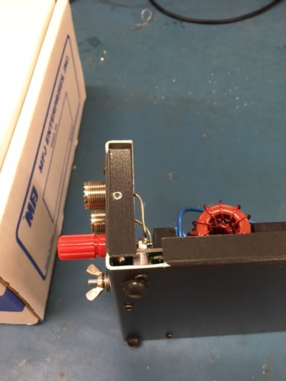

**Figure 3.2c - MFJ-998**

Aluminum and steel are both sturdy enough for mounting and anchoring. Table 3.6 elaborates on more qualities of each material.

**Table 3.2e - Aluminum vs. Stainless Steel**

|  |  |  |
| --- | --- | --- |
| **Material** | Stainless Steel | Aluminum |
| **Manufacturing times[27][28]** | Varies but typically higher than aluminum | Varies but typically lower than aluminum |
| **Weight per cu./ft in pounds[29]** | 494.21 | 168.48 |
| **Price per lb.[30][31]** | $0.92 | $1.62 |

Aluminum is the best option due to its low manufacturing times, weight, and availability. MFJ typically opts for aluminum enclosures for most of its products but will use steel if a larger component like a transformer is being supported. In addition, MFJ has built relationships with suppliers that allow them to get sheets of aluminum prefabricated with extra protective coatings.  Aluminum offers several advantages over both steel and stainless steel. Since aluminum is a softer and more malleable metal, it reduces manufacturing times compared to equivalent steel enclosures [27][28]. Not only does it save time during production, but it also poses less strain on the equipment forming it. Standard steel would also require some type of coating like paint or varnish to help protect from the environment. Given the same environment, aluminum and steel have similar lifetimes.  Having a lower weight gives aluminum advantage over stainless steel in scenarios of handling and leads to lower shipping cost. Steel is a stronger metal but for protecting MFJ equipment, aluminum has proven satisfactory per customer feedback.

**3.2.8 LCD Display**

The Intellitune will feature a two-line, 16-character LCD display on the front panel that will show the SWR reading, forward and reflected power, and frequency. Table 3.7 compares three options the team considered.

**Table 3.2f - LCD Display Comparison**

|  |  |  |  |
| --- | --- | --- | --- |
| **LCD** | **Characters** | **Interface** | **Price** |
| Adafruit 181 [32] | 16x2 | GPIO | $9.95 |
| NHD-0216K3Z-NSW-BBW-V3 [33] | 16x2 | I2C | $19.85 |
| Adafruit 198 [34] | 20x4 | GPIO | $17.95 |

Although the Adafruit 181 is the least expensive of the selection pool, it still provides the necessary parallel operation mode for easy interfacing with the microcontroller. Additionally, the backlight brightness is controlled by a DC voltage input and can be varied easily with a potentiometer.

**3.3 Software**

The Intellitune software will be developed in the Ti Code Composer Studio (CCS) IDE. Personal experience determined that this environment was best suited for the selected microcontroller. With integrated device support and quick flashing capabilities, frequent testing of code will promote rapid development. The selected microcontroller features a JTAG interface, which communicates with the IDE in runtime. This allows register or variable values to be read and breakpoints to be placed at points of interest.

**3.3.1 Impedance Matching Algorithm**

The primary software component in the Intellitune is the tuning algorithm, which will tie in all the developed subsystems. Figure 3.8 shows a diagram of the tuning process.

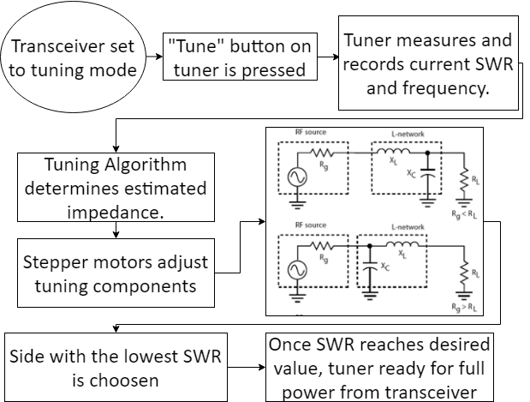

**Figure 3.3d - Tuning Process**

In the control circuit, a small portion of the transmitted RF signal is converted to a square wave using a Schmidt trigger and fed to the microcontroller to determine the frequency of the transmitted wave. As the RF signal passes through the wideband current transformer, forward and reflected power are derived as a pair of voltage signals and are routed to the microcontroller. With these inputs, the microcontroller executes the tuning algorithm which determines a conjugate match of the load impedance for the source to enable maximum power transmission. This conjugate impedance is introduced with the variable tuning components. The microcontroller commands the stepper motor drivers to rotate the variable components to the correct configuration for the matched impedance. If the capacitance calculated is greater than the total capacitance of the variable capacitor, additional capacitance is switched in with relays. A separate relay then switches the capacitor on either side of the inductor to determine which configuration presents the lowest VSWR. Incremental adjustments are performed afterward until the user defined VSWR is met, which must be below 2:1. This concludes the tuning process, and the user is free to operate at full transmission power for the tuned frequency.

**3.3.3 Variable Inductance and Capacitance**

The Intellitune’s software must accomplish two primary tasks relevant to the variable inductance and capacitance: it will interface with the stepper motor drivers to adjust the variable tuning components, and it will correlate an analog voltage input to a capacitance or inductance reading.

Three pin connections between the microcontroller and stepper driver are required for each motor and driver combo. The three signal inputs are a direction control, enable, and step. Each time a pulse is sent to the step input, the motor is incremented one step in the controlled direction. The software will increment or decrement the capacitance or inductance based upon the tuning algorithm output. The software will also keep track of the variable components’ location for future tuning.

**3.3.2 User Interface**

The user interface will feature six push buttons for the following actions: power on/off, tune, capacitance up, capacitance down, inductance up, and inductance down. When powered off, the tuner will still allow power to be transmitted through the tuner, but the tuning components will not change values and the user interface will not be powered. This mode of operation is strongly discouraged for users because it will likely damage components in the control circuit. When powered on, the tune button can be pressed to begin the automatic tuning process. The up and down buttons for the variable components allow the user to adjust the component values manually if they believe a lower SWR is possible. The software will have hardware interrupts tied to the button inputs, so fast response to user changes can be achieved. In addition, SWR, frequency, forward power, and reflected power are the default settings displayed on the LCD, per MFJ standards. However, when either of the capacitance or inductance buttons are pressed, the LCD must display the current settings for the tuning components, so the user can observe how they are changing.

**3.3.3 Usage Cases**

In a “sunny-day” scenario (shown in Figure. 3.5), the Intellitune will tune the connected antenna at a low power until the SWR is below the user-defined limit, which ranges between 1.1:1 and 2:1. After the tuning process is complete, the user will be able to transmit at the rated power to their antenna. A notification on the LCD will alert the user when tuning is complete.

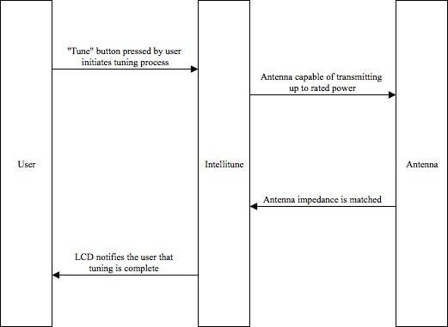

**Figure 3.3a - Sunny Day Scenario**

A “rainy-day” scenario (shown in Figure 3.3b) for the Intellitune occurs when the VSWR is above the limit of 2:1 and the user attempts to transmit at high power. At a high transmitting power, a mismatch above this limit indicates that a nominal amount of power is being reflected to the transmitter. The reflected power can result in substantial damage to the user’s equipment. A warning message will be sent to the user via the LCD and the tuner will cease operation.

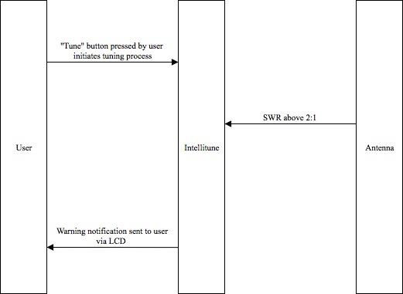

**Figure 3.3b - Rainy Day Case 1**

Figure 3.7 summarizes another “rainy-day” scenario where the transmitter does not supply enough power to tune the network; matching impedance requires a minimum of 10W in the Intellitune. Without meeting this power level, there is no way for the ATU to register the frequency to which the transmitter changed.

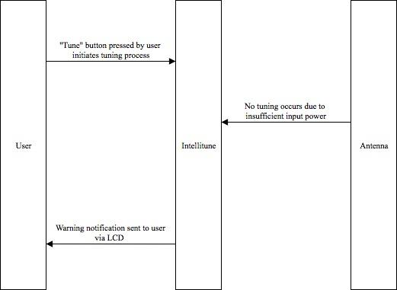

**Figure 3.3c - Rainy Day Case 2**

# Evaluation

This section demonstrates the test and evaluation of each subsystem of Intellitune against the stated technical design constraints. Each of these individual subsystems ensure that the constraints described in Table 4.1 are met and verify that they are ready to be integrated into the final product. The subsystem tests are followed by a system test at the end that demonstrates the subsystems can function successful as one entire product.

**Table 4 - Technical Design Constraints**

|  |  |
| --- | --- |
| **Name** | **Description** |
| Power Rating | The Intellitune must be capable of handling 1.5 kW of transmitting power. |
| Bandwidth | Tuning circuitry must pass through frequencies in the 1.5 MHz to 30 MHz band. |
| VSWR Sensing | The Intellitune must measure the forward and reflected power to determine the voltage standing wave ratio (VSWR) for up to a 32:1 mismatch. |
| Frequency Sampling | The microcontroller must sample the transmitting signal and determine the frequency up to the maximum 30 MHz limit. |
| Impedance Matching | The Intellitune must provide a tuning network that is capable of matching antenna impedances from 12-1600 ohms. |

**4.1 Test Certification -  User Interface**

The user interface of Intellitune is located on the front panel and comprised of the LCD display and push buttons. The LCD display will show the user the VSWR reading, forward and reflected power, and the frequency. The user can send a command to the microcontroller by pressing its respective button. Additionally, if the mode button is held down for more than two seconds, a settings menu appears. The available buttons are Tune, Inductance-Up, Inductance-Down, Capacitance-Up, Capacitance-Down, Antenna, and Mode. For the evaluation of this subsystem, a test was conducted where each button was pressed individually, and it was verified that the appropriate action was triggered. The table below summarizes these tests.

**Table 4.1 Push Button Checklist**

|  |  |  |
| --- | --- | --- |
| **Button** | **Expected function** | **Status** |
| Tune | Initiate tuning process | Functional |
| Inductance-Up | Turn variable inductor to add additional inductance | Functional |
| Inductance-Down | Turn variable inductor to decrease additional inductance | Functional |
| Capacitance-Up | Turn variable inductor to add additional capacitance | Functional |
| Capacitance-Down | Turn variable inductor to decrease additional capacitance | Functional |
| Antenna | (Currently un-utilized) | N/A |
| Mode | Cycles through the different displays | Functional |
| Settings Menu (triggered by mode button) | Pulls up the available settings for the tuner | Functional |

**4.2 Test Certification - Wideband Current Transformer**

The wideband current transformer is an essential design constraint for sensing the VSWR. This subsystem satisfies the technical constraint of measuring the forward and reflected power to determine the VSWR for up to a 32:1 mismatch. The procedure for this test began with connecting a 50-ohm load to Intellitune’s antenna output to calibrate for a 1.0 VSWR reading. Next, different known loads were connected to verify that the experimental reflection coefficient was close to the theoretical value. In addition to this, there was an external VSWR meter attached in series to confirm that the readings from Intellitune’s wideband current transformer were in fact close to the actual value.

In Figure 4.2a below, the oscilloscope display shows the forward and reflected voltages measured during the test. Channel one is measured at 1.44 Volts and channel two shows 112 mV. Using the formula for calculating VSWR shown in Figure 4.2b, the reflection coefficient is found, and then using 4.2c, the Intellitune found the VSWR to be 1.168.

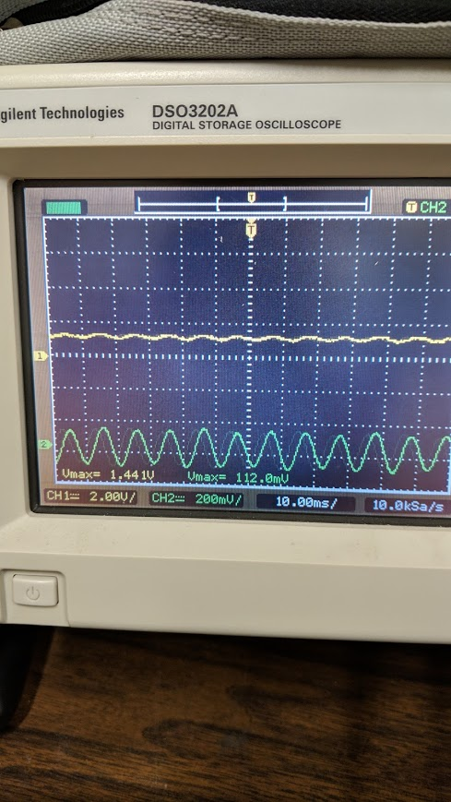

**Figure 4.2a Oscilloscope reading of forward and reflected voltages**

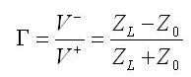

**Figure 4.2b Formula used to calculate reflection coefficient (gamma) where V- is the reflected wave and V+ is he incident wave**

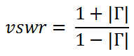

**Figure 4.2c Formula used to calculate VSWR using gamma**

In Table 4.2 below, the value of the load is varied for each test. The expected VSWR was derived using the reflection coefficient calculated from the impedance of the load. An external VSWR meter was attached in series to confirm that the values matched Intellitune’s, and the percent error the two were recorded in the table.

**Table 4.2 VSWR Sensor Test Data**

|  |  |  |  |  |
| --- | --- | --- | --- | --- |
| **Resistance** | **Expected SWR** | **External VSWR Reading** | **Intellitune VSWR Reading** | **% Error** |
| 50 Ohm | 1.0 | 1.1 | 1.168 | 6.2% |
| 100 Ohm | 1.71 | TBD | TBD | TBD |
| 25 Ohm | 1.71 | TBD | TBD | TBD |

**4.3 Frequency Counter Testing**

The frequency counter subsystem utilizes the frequency counter circuit and the microcontroller to satisfy the technical constraint of sampling the transmitted signal and determining the frequency up to 30 MHz. For testing, the waveform generator in Figure 4.2 was used to send a square wave signal to the microcontroller at various frequencies. The calculated frequency was then displayed on the LCD. After the first successful test, additional tests were performed where the frequency, waveform type, and voltage were varied across each test to ensure complete functionality. Test results of the frequency counter are shown in Table 4.2, and the frequency counter was found to be accurate up to 3 decimal places as shown in Figure 4.3.

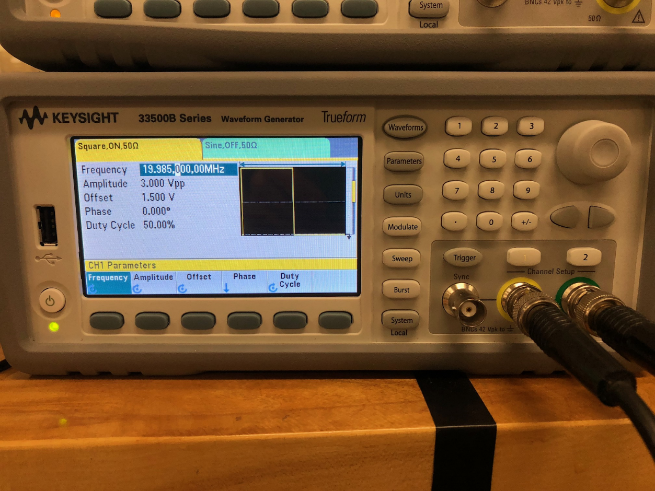

**Figure 4.3a - Waveform Generator Test Setup**

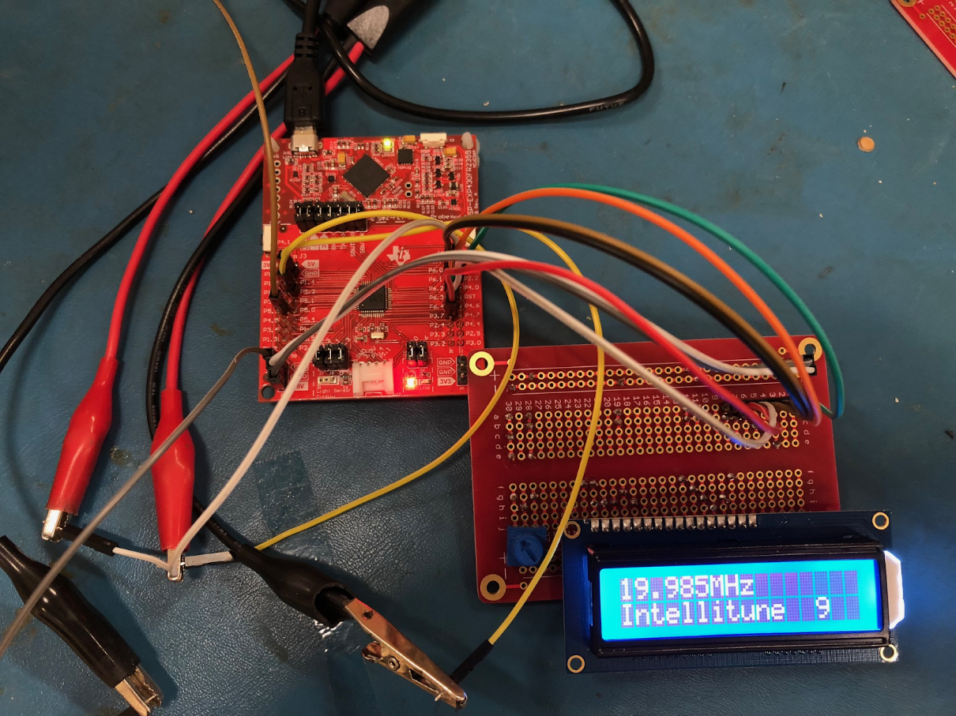

**Figure 4.3b - Test Results of 19.985 MHz Sampled Frequency**

|  |  |  |  |
| --- | --- | --- | --- |
| **Frequency Generated** | **Waveform Type** | **Voltage (Vpp)** | **Frequency Sampled** |
| 3.622 MHz | sine | 3.0 | 3.622 MHz |
| 3.622 MHz | square | 3.0 | 3.622 MHz |
| 19.15 MHz | sine | 4.0 | 19.15 MHz |
| 19.15 MHz | square | 4.0 | 19.15 MHz |

**Table 4.3 Frequency sampling test cases**

**4.4 Test Certification - Stepper Motor Subsystem**

The stepper motor subsystem consists of the driver code on the microcontroller, two stepper motors, and two stepper motor drivers. Together, these components adjust the variable inductor and the variable capacitor to achieve the needed impedance. The first step of evaluating this subsystem was to use the microcontroller to command the motors to rotate without connection to the variable components. Once it was confirmed that the motors were rotated successfully, the motors were then attached to the variable components. Once again, the microcontroller was used to turn the stepper motors. Afterwards, the shafts were checked for slippage or dislocation so that it could be confirmed that the parts were connected firmly.

When integrated with the system, it was possible to check to ensure that the proper amount of inductance or capacitance was being added. When the tuning algorithm begins, the LCD display shows an estimated impedance, which is the impedance that the microcontroller believes that Intellitune needs to add. The stepper motors will then rotate the variable components to this estimated impedance, and then begin a fine tuning process to get the precise value. This information is further outlined in the system test section.

**4.5 Relay Circuit Subsystem**

The relay circuit subsystem is responsible for switching in certain capacitors during the tuning algorithm. Due to the complexity of the circuit, it is crucial to test this subsystem to ensure that everything is assembled correctly before proceeding. To perform this test, the microcontroller was programmed to call out commands that would execute the switching of the relays. The switch of each relay is audible so hearing that sound is the first signal that the relay is functioning. After the switching noise was heard, a multimeter was used to ensure that the internal configuration of the relay routed the wiring properly. Table 4.5 describes the test process in full.

**Table 4.5 Relay Circuit Test Summary**

|  |  |  |  |
| --- | --- | --- | --- |
| **Relay Number** | **Description** | **Audible Noise** | **DMM Check** |
| 1 | variable inductor relay | heard | Connectivity present |
| 2 | 470 pF cap relay | heard | Connectivity present |
| 3 | 940 pF relay | heard | Connectivity present |
| 4 | 1,410 pF relay | heard | Connectivity present |
| 5 | 25 Ohm relay | heard | Connectivity present |

**4.6 Test Certification - Impedance Matching Code**

The microcontroller executes the impedance matching code in order to satisfy the design constraint of providing a tuning network that is capable of matching antenna impedances from 12 to 1600 ohms. The first step of the test was to input the dummy reflection coefficient to verify the algorithm calculations. Next, known dummy loads were connected, and then it was verified that the correct load and VSWR were calculated. After that, the motors were inspected to ensure that they adjusted to the calculated tuning values.

**4.7 Test Certification- Power Handling Capability**

The final Intellitune must be capable of handling 1.5 kW. For the prototype this semester, the aim is to operate at 50 W. Further testing for the power handling capability will be executed next year as part as the system test.

**4.8 System Test**

After all of the subsystems proved to be function, various system tests were executed in order to verify functionality of Intellitune. In each test, the dummy load is varied, as well as the power level and the frequency. The first step was to place Intellitune between the transceiver and the dummy load. Next, FM signals were transmitted at different frequencies and powers described in Table 4.8. In each case, the initial VSWR reading was noted for later comparison. After setup is complete, the tuning process was initiated using the push button on the user interface. When the tuning algorithm completed its cycle, the resulting VSWR data was compared to the expected.

For this semester, the frequencies will be kept relatively low to avoid stray capacitance, however this should not remain an issue next semester after the printed circuit board (PCB) is manufactured, and there are less wires. Additionally, the power will be kept under 50 watt until Intellitune can be reinforced and made more robust next semester. Before the system test begins, it is expected that there will be an VSWR greater than two, so the goal is to lower that measurement to somewhere below two. A summary of this test is described in the table below.

**Table 4.8 System Test Cases**

|  |  |  |  |  |  |
| --- | --- | --- | --- | --- | --- |
| **Frequency** | **Transmitted Power** | **Load** | **Initial SWR reading** | **Initial Calculated SWR** | **Final Measured SWR** |
| 18.07 MHz | 20 W | 100 Ohms  1.36 uH  54.48 nF | 3.3 | 3.3 | 1.3 |
| 7.04 MHz | 15 W | 100 Ohms  2.6 uH  136.8 nF | 2.5 | 2.0 | 1.4 |
| 7.02 MHz | 15 W | 100 Ohms  1.3 uH  51.36 nF | 1.7 | 1.5 | 1.3 |

# Summary and future work

This semester, the team accomplished a great deal with Intellitune. In the end, team Intellitune was able to demonstrate a working prototype of our automatic ham radio antenna tuner. Despite the ultimate success, this semester held many challenges, and there are many challenges that lie ahead. This summary will go into detail about our success, our issues, and future challenges.

Ultimately, Intellitune was successful on demonstration day. The product was able to measure the SWR between the transmitter, and an unmatched dummy load, and calculate the estimated impedance required to make a match between the two. After that, the microcontroller was able to command the stepper motors to rotate the variable components to the appropriate position so that they added that estimated impedance. Next, the microcontroller ran a tuning algorithm that continued to fine tune until an optimal SWR reading was obtained. The completion of this process demonstrated that the product was successful in automatically tuning a ham radio antenna.

The biggest issue our team faced this semester was radio frequency interference (RFI) that kept the digital side of the project from working. Each subsystem was tested individually before the system test, however, once they were all integrated, the system began to face difficulties. Upon investigation, the hypothesis formed was that the radiation of the RF components was interfering with the LCD display and possibly the microcontroller. The team determined that somehow, the RF radiation from the components needed to be blocked to avoid the interference. This issue was solved by enclosing RF components in a metal enclosure which blocked the interference since the enclosure was conductive. After interference was contained, the team was able to proceed with debugging the rest of the system.

Even though the team was able to block out most of the RF interference this semester, there is still room for improvement in this aspect. Intellitune was limited to the frequencies and power that it could operate on due to this interference, and going forward to the next semester, this is something that needs to be improved upon. One thing that will eliminate most of this problem is designing a printed circuit board for Intellitune instead of having components spread throughout multiple breadboards. The elimination of the breadboards will also eliminate the amount of wires that are spread about and able to pick up RF radiation. This will allow Intellitune to operate at a higher power and higher frequency than before. The group also plans to find other additional methods of blocking the RF interference and implement those into the project as well. The combination of using a printed circuit board and other RF blocking methods will increase the power and frequency abilities significantly.

One other issue that must be improved upon is the product size. Currently, the product is much too large to be seem as an attractive option for ham radio users, and the group will have to work to reduce the size. One thing that will automatically help shrink Intellitune’s physical footprint will be the creation of the printed circuit boards. However, a challenge with shrinking the size of the product is still keeping the RF interference out while packing the components in tighter. This will definitely leave the team with some problem solving to do in the future.

Over the course of the semester, team Intellitune learned a great deal about antennas, ham radio and project design. There were many failures to overcome, however, with persistence and determination, we were able to develop a working prototype in only a few months. The upcoming challenges that the team will focus on primarily are decreasing the radio frequency interference and also decreasing the physical size of Intellitune. The group has learned a lot so far, and looks forward to what all they will learn in the upcoming senior design semester.

# Acknowledgements

We would like to acknowledge Dr. Torston Clay, Mississippi State’s ham radio club sponsor, for his assistance in the project, and allowing us to borrow equipment from the club. The project would not have been possible without the generous donation of the club’s assets. Additionally, we acknowledge Martin Jue of MFJ enterprises for sponsoring our design team.

# References

[References must be formatted precisely according to current IEEE guidelines; two convenient locations for these guidelines are the Shackouls TCP’s handout on documenting sources in IEEE style and chapter 12.1 of the textbook for GE 3513, A Writer’s Handbook for Engineers.]

[1] J. Maxwell, “Amature Radio: 100 Years of Discovery,” ARRL: The National Association of Amateur radio, 01-Jan-2000. [Online]. Available: http://www.arrl.org/files/file/About ARRL/Ham_Radio_100_Years.pdf. [Accessed: 27-Aug-2018].

[2] wireless2.fcc.gov. (2018). License Search - Amateur License Search. [online] Available at: http://wireless2.fcc.gov/UlsApp/UlsSearch/searchAmateur.jsp [Accessed 29 Aug. 2018].

[3] LII / Legal Information Institute. (2018). 47 CFR 97.301 - Authorized frequency bands. [Online] Available: https://www.law.cornell.edu/cfr/text/47/97.301 . Accessed: 19 Sep. 2018.

[4] MFJ Enterprises, Inc., Starkville, MS, USA, “MFJ-9982,” Available: https://www.mfjenterprises.com/Product.php?productid=MFJ-9982. Accessed: 18 Sep. 2018.

[5] MFJ Enterprises, Inc., Starkville, MS, USA, “MFJ-998,” Available: https://www.mfjenterprises.com/Product.php?productid=MFJ-9982 . Accessed: 18 Sep. 2018.

[6] Eugene Ungar and Kenneth Stroud, “A New Approach to Defining Human Touch Temperature Standards,” NASA/Johnson Space Center, Houston, TX, USA. [Online]. Available: https://ntrs.nasa.gov/archive/nasa/casi.ntrs.nasa.gov/20100020960.pdf . Accessed: 19 Sep. 2018.

[7] IEEE Standard for Safety Levels with Respect to Human Exposure to Radio Frequency Electromagnetic Fields, 3 kHz to 300 GHz, in *IEEE Std C95.1-2005*, pp.1-238, 19 April 2006. [Online]. Available: http://ieeexplore.ieee.org/stamp/stamp.jsp?tp=&arnumber=1626482&isnumber=34126 . Accessed: 19 Sep. 2018.

[8] “MFJ-1312DX”, mfj.com, 2018. [Online]. Available: https://www.mfjenterprises.com/Product.php?productid=MFJ-1312DX. Accessed: Oct. 18, 2018.

[9] ”Supernight 12V Power Supply”, amazon.com, 2018. [Online]. Available: https://www.amazon.com/SUPERNIGHT-110-240V-Transformer-Adapter-5-5x2-1mm/dp/B00K6AHNWC. Accessed: Oct. 18, 2018.

[10] ”Binzet AC to DC 12V 10A 120W Power Supply”, amazon.com, 2018. [Online]. Available: https://www.amazon.com/BINZET-Adapter-Converter-Regulator-Flexible/dp/B00Z9X4GLW. Accessed: Oct. 18, 2018.

[11] “Back to Basics in Microwave Systems: Return Loss and VSWR”, commonscope.com, 2018. [Online]. Available: https://www.commscope.com/Blog/Back-to-Basics-in-Microwave-Systems-Return-Loss-and-VSWR/. Accessed: Oct. 4, 2018.

[12] “Basics of Current Transformer,” engineeringtutorial.com, 2018. [Online]. Available: https://engineeringtutorial.com/basics-of-current-transformer/. Accessed: Oct. 4, 2018.

[13] “Arduino Uno Rev3”, arduino.cc, 2018. [Online]. Available: https://store.arduino.cc/usa/arduino-uno-rev3. Accessed: Sep. 23, 2018.

[14] “Raspberry Pi 3 Model B+”, raspberrypi.org, 2018. [Online]. Available: https://www.raspberrypi.org/products/raspberry-pi-3-model-b-plus/. Accessed: Sep. 23, 2018.

[15] “MSP430FR2355 LaunchPad Development Kit”, ti.com, 2018. [Online]. Available: http://www.ti.com/tool/MSP-EXP430FR2355. Accessed: Sep. 23, 2018.

[16] “Nema 23 Bipolar 1.8 degree 2.4Nm(340 oz.in) 1.8A 4.95V 57x57x104mm 4 wires”, stepperonline.com, 2018. [Online]. Available: https://www.omc-stepperonline.com/hybrid-stepper-motor/nema-23-bipolar-18deg-24nm-340ozin-18a-495v-57x57x104mm-4-wires-23hs41-1804s.html?mfp=149-step-angle%5B1.8%5D%2C145-holding-torque-ncm%5B190%2C220%2C240%2C250%2C280%2C283%2C300%2C310%2C340%2C400%2C450%2C707%2C850%2C1300%2C2200%2C3000%5D. Accessed: Sep. 21, 2018.

[17] “Nema 17 Stepper Motor Bipolar L=33mm w/ Gear Ratio 27:1 Planetary Gearbox”, stepperonline.com, 2018. [Online]. Available: https://www.omc-stepperonline.com/nema-17-stepper-motor-bipolar-l33mm-w-gear-raio-271-planetary-gearbox-17hs13-0404s-pg27.html. Accessed: Sep. 21, 2018.

[18] “Nema 11 Stepper Motor Bipolar L=51mm w/ Gear Ratio 100:1 Planetary Gearbox”, stepperonline.com, 2018. [Online]. Available: https://www.omc-stepperonline.com/geared-stepper-motor/nema-11-stepper-motor-bipolar-l51mm-w-gear-raio-1001-planetary-gearbox-11hs20-0674s-pg100.html. Accessed: Sep. 21, 2018.

[19] “1460-1078-ND”, digikey.com, 2018. [Online]. Available: https://www.digikey.com/product-detail/en/trinamic-motion-control-gmbh/QSH5718-51-28-101/1460-1078-ND/4843429. Accessed: Sep. 21, 2018.

[20] “[3D CAM] 2 PCS Flexible Couplings 5mm to 8mm NEMA 17 Shaft for RepRap 3D Printer or CNC Machine”, amazon.com, 2018. [Online]. Available: https://www.amazon.com/3D-CAM-Flexible-Couplings-Printer/dp/B010MZ8T2S. Accessed: Sep. 21, 2018.

[21] “Aluminum Flex Shaft Coupler - 5mm to 10mm”, adafruit.com, 2018. [Online]. Available: https://www.adafruit.com/product/1177?gclid=EAIaIQobChMImvDt2Y_N3QIVmY-zCh1Q4AjKEAkYDSABEgKSofD_BwE. Accessed: Sep. 21, 2018.

[22] “Flexible Parallel Aluminium Jaw Shaft CNC Coupling D19-L25-3x5MM”, vxb.com, 2018. [Online]. Available: https://www.vxb.com/Flexible-Parallel-CNC-Coupling-D19-L25-3X5M-p/D19-L25-3X5MM-COUPLING.htm?gclid=EAIaIQobChMImvDt2Y_N3QIVmY-zCh1Q4AjKEAkYDyABEgKJnvD_BwE. Accessed: Sep. 21, 2018.

[23] “Big Easy Driver”, sparkfun.com, 2018. [Online]. Available: https://www.sparkfun.com/products/12859. Accessed: Oct. 16, 2018.

[24] “EasyDriver - Stepper Motor Driver,” sparkfun.com, 2018. [Online]. Available: https://www.sparkfun.com/products/12779. Accessed: Oct. 6, 2018.

[25] “Adafruit Motor/Stepper/Servo Shield for Arduino v2 Kit - v2.3”, adafruit.com, 2018. [Online]. Available: https://www.adafruit.com/product/1438. Accessed: Oct. 5, 2018.

[26] “1460-1159-ND,” digikey.com, 2018. [Online]. Available: https://www.digikey.com/product-detail/en/trinamic-motion-control-gmbh/TMC%2520SILENTSTEPSTICK/1460-1159-ND/5724190?WT.srch=1&gclid=EAIaIQobChMIk8-Ou5T63QIVCJyzCh0TjgHkEAYYASABEgKAzfD_BwE.  Accessed: Oct. 4, 2018.

[27] [Adam Hornbacher](https://plus.google.com/109972614238550156361?rel=author), “Steel versus Aluminum Weight, Strength, Cost, Malleability Comparison”, wenxelmetalspinning.com, 2018. [Online]. Available: https://www.wenzelmetalspinning.com/steel-vs-aluminum.html. Accessed: Sep. 21, 2018.

[28] Metal Supermarkets, “10 DIFFERENCES BETWEEN ALUMINUM AND STAINLESS STEEL”, metalsupermarkets.com, 2018. [Online]. Available: https://www.metalsupermarkets.com/10-differences-aluminum-stainless-steel/. Accessed: Sep. 21, 2018.

[29] “Weights of Various Metals in Pounds Per *Cubic Foot”, coyotesteel.com, 2018. [Online]. Available: http://www.coyotesteel.com/assets/img/PDFs/weightspercubicfoot.pdf.  Accessed: Sep. 21, 2018.

[30] “Aluminum Prices and Aluminum Price Charts”, infomine.com, 2018. [Online]. Available:

http://www.infomine.com/investment/metal-prices/aluminum/.  Accessed: Sep. 21, 2018.

[31] “Stainless Steel”,  agmetalminer.com, 2018. [Online] Available: https://agmetalminer.com/metal-prices/stainless-steel/.  Accessed: Sep. 21, 2018.

[32] “Standard LCD 16x2 + extras - white on blue”, adafruit.com. 2018. [Online]. Available: https://www.adafruit.com/product/181.  Accessed: Sep. 25, 2018.

[33] “NHD-0216K3Z-NSW-BBW-V3”, newhaven.com, 2018. [Online]. Available: http://www.newhavendisplay.com/nhd0216k3znswbbwv3-p-5739.html. Accessed: Sep. 25, 2018.

[34] “Standard LCD 20x4 + extras - white on blue”, adafruit.com, 2018. [Online]. Available: https://www.adafruit.com/product/198. Accessed: Sep. 25, 2018.

# Appendix: Product specification

